***Exercise 1: Mocking and Stubbing***

To test a service that depends on an external API using Mockito by mocking the API and stubbing its methods, and verifying the output with JUnit.

**Tools & Technologies Used**

* Java
* Eclipse IDE
* Maven (for dependency management)
* JUnit 5
* Mockito

Code Explanation and Screenshots

**ExternalApi.java**

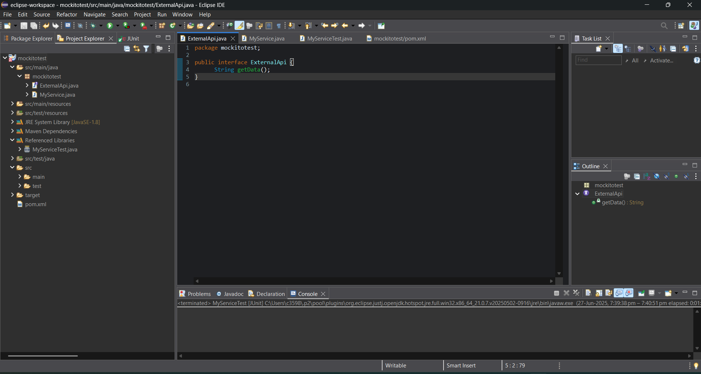

***MyService.java***

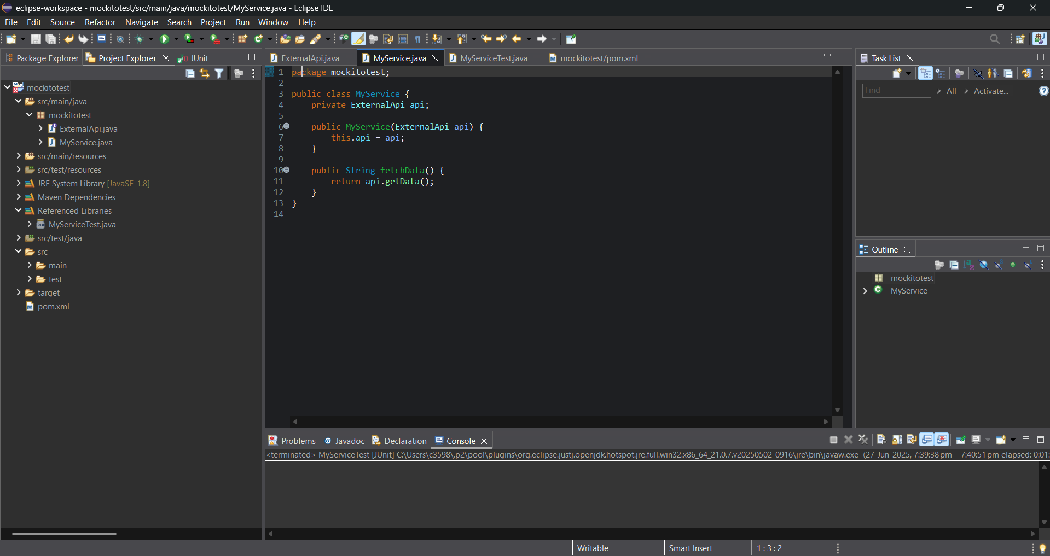

MyServiceTest.java

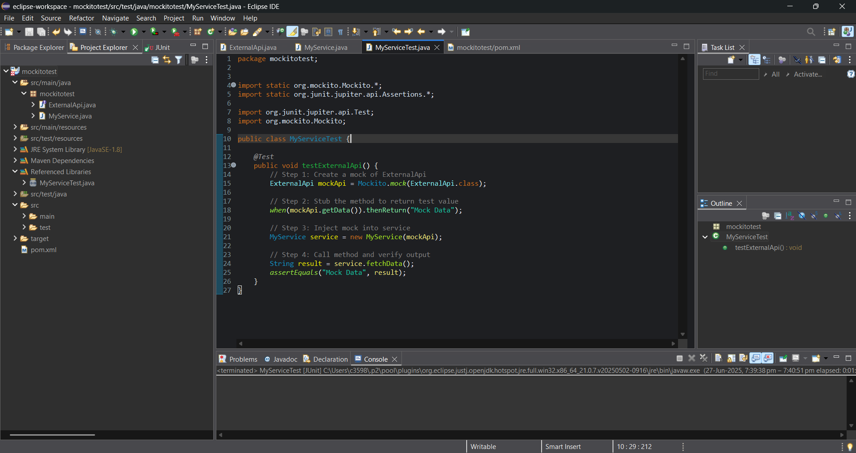

pom.xml (Dependencies Section)

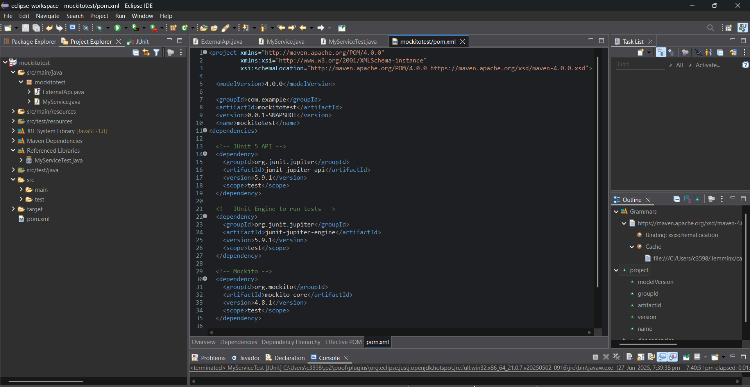

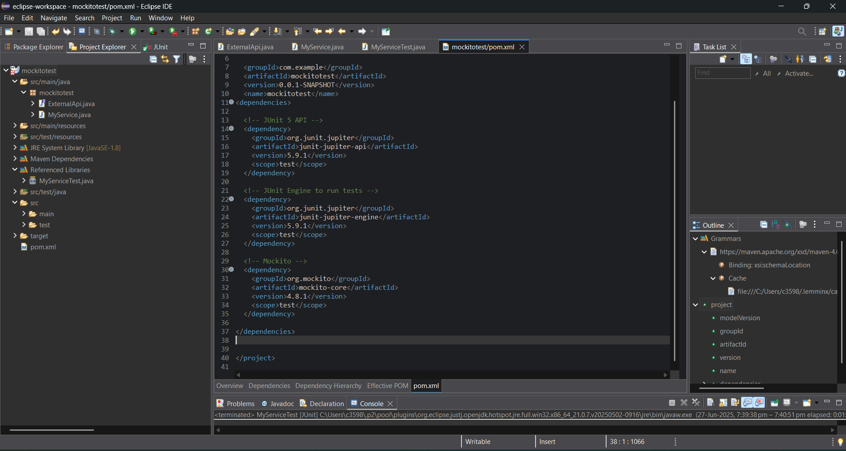

***OUTPUT***  
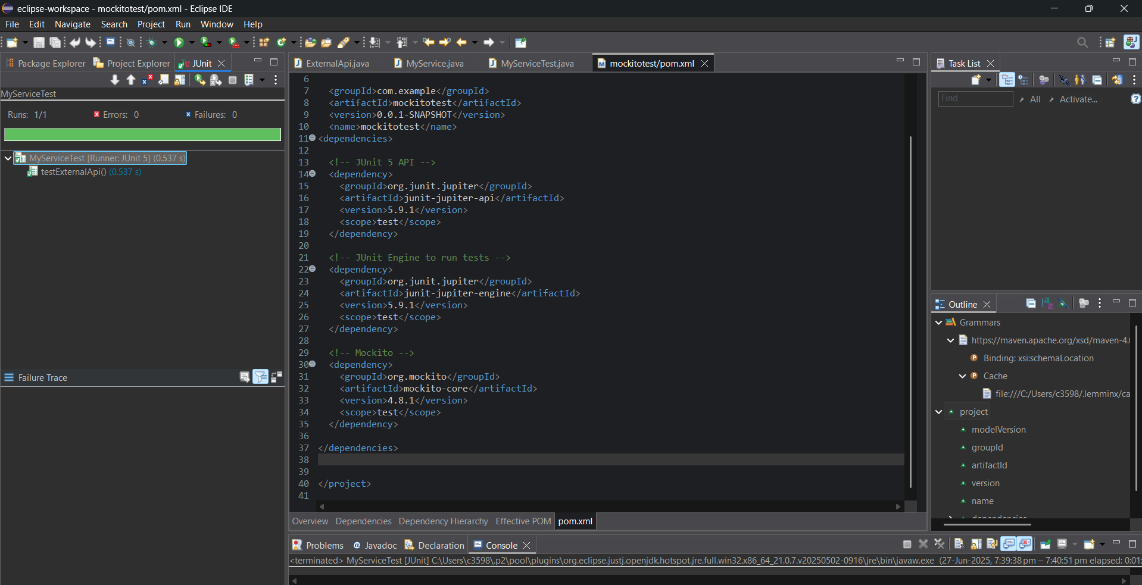

***Exercise 2: Verifying Interactions***

Scenario: You need to ensure that a method is called with specific arguments

Mockito verify() method is used to ensure that a specific intraction occurred.

import static org.mockito.Mockito.*;

import org.junit.jupiter.api.Test;

import org.mockito.Mockito;

public class MyServiceTest {

@Test

public void testVerifyInteraction() {

ExternalApi mockApi = Mockito.mock(ExternalApi.class);

MyService service = new MyService(mockApi);

service.fetchData(); // Call the method

verify(mockApi).getData(); // Verify that getData() was called

}

}

OUTPUT

